CONVENTION ON THE ELIMINATION OF ALL FORMS OF DISCRIMINATION AGAINST WOMEN

ALTERNATIVE REPORT TO THE COMMITTEE
INCLUDING SPECIFIC REFERENCES TO THE SITUATION OF WOMEN AND GIRLS WITH DISABILITIES AND PROPOSED RECOMMENDATIONS

FOR THE 87th SESSION
29 January–16 February 2024

BY the ITALIAN DISABILITY FORUM
28th DECEMBER 2023

Table of contents

Background Information about FID 3
Introduction 4
General 4
Impact of the pandemic on women’s rights, recovery, and gender equality 6
Legislative, policy and institutional framework 8
Legal capacity and access to justice 10
National mechanism for the advancement of women 12
Stereotypes and harmful practices 13
Gender-based violence against women 14
Trafficking and exploitation of prostitution 19
Education 20
Employment 24
Health 30
Refugee, asylum-seeking and migrant women 32
Additional information 33

The text was drafted by the Italian Disability Forum’s CEDAW Ad Hoc Working Group coordinated by Luisa Bosisio Fazzi and composed of Laura Abet, Patrizia Cegna, Silvia Cutrera, Giulia Grazioli, Giampiero Griffo and Francesca Sbianchi.
Please note that the text has been edited following accessibility criteria.

- It should be noted that (SR xxx) refers to the answers of the State Party Report

Introduction

In January 2021, FID sent to the CEDAW Committee its considerations, and proposed List of issues, about the serious discrimination and violation of human rights that girls and women with disabilities suffer in Italy.
The information and answers submitted by State Party Italy related to girls and women with disabilities are incomplete and do not demonstrate the full application of the CEDAW. In our country, girls and women with disabilities experience daily invisibility and discrimination. Furthermore, the lacking mainstreaming approach added to gender and disability stereotypes has deleterious effects on their quality of life and their full, effective, and equal participation in society.
Wishing to include women with disabilities’ needs in the general women’s movement document, FID also cooperated in the drafting of the Alternative Report of “Italian civil society organizations for CEDAW” coordinated by D.i.Re - Donne in Rete contro la violenza.

General

Disaggregated data collection is essential and an important tool for understanding and monitoring the phenomenon, and identifying the most effective political interventions. Until now we have asked for data collection and statistics to be produced with at least a breakdown by gender and type of disability.
(SR 1): The document "Implementation of the Integrated Information System: collection and analysis of data on the phenomenon and on the various articulations", referred to in the reply, does not mention disaggregating data also by disability.
Last year, the Parliament approved “Law 53/2022 Provisions on gender-based violence statistics” and from January 1st 2023 this law should have begun to be applied. It establishes that statistics and data must be disaggregated by gender but not by disability.
On August 7th, 2023 ISTAT published a research report entitled 'Protection System for Women Victims of Violence' 2021- 2022. This report contains some data on accessibility in Women’s Shelter and Anti-Violence Centres (CAVs) and Helpline 1522, but the real accessibility of the facilities is not known, and the disability of the victims and direct accessibility to information and to the services are not mentioned. The adequacy of risk assessment instruments is not considered, and disability training for staff is minimal. It should be noted that 94.1% of the 337 centres/shelter responding to the ISTAT questionnaire adopted criteria of guest exclusion. This is missing in the text of the ISTAT report; the information is in Tables 16 and 17 included in the Excel file with data on Women’s Shelters (year 2021). Regarding SR5 and SR6, it is not known whether the above statistics have been activated or their indicators have been developed to show data disaggregated by disability as well as gender. Moreover, (SR7) we don’t know whether the above transversal measures have been adopted and monitored or if there are training initiatives in schools and universities, or awareness-raising campaigns on and for girls and women with disabilities have been activated. Again, (SR 9) women with disabilities are not included in the above publications.

Recommendation
Enhance the collection of disaggregated data by type of disability, gender, and age considering all persons with disabilities in all areas of life, including children and persons with intellectual, developmental, and psychosocial disabilities and institutionalized persons.

Impact of the pandemic on women’s rights, recovery, and gender equality

Referring to FID’s previous 2021 document, it’s important to specify that In Italy, since the beginning of the COVID 19 emergency, the situation of exclusion and neglect faced by women with disabilities has further worsened.
Human rights were violated in three main areas:
1) lack of equal access to health care;
2) poor intervention capacity in emergencies and with protection systems;
3) inadequate care of people in long-term facilities, and inadequate monitoring of the situation.
This resulted in a high number of deaths in residential settings -where the majority of residents were women-, the confinement of persons with disabilities at home without considering their needs and requirements, the lack of data on the provisions for alternative measures. The fact that 3 million families with one or more persons with disabilities were left out in the cold brought further neglect and abuse as well as exacerbated gender-based violence and domestic violence towards girls and women, especially those with disabilities.
It must be reported that during the vaccination campaign, the systems to book appointments for vaccinations, which were only available online, were not accessible to assistive technologies used by persons with visual impairment.
SR 10: FID considers that among the proposals in the “Women for a new Renaissance” document, women with disabilities are mentioned in two points with a view to bridging the digital divide, but without dedicated actions.
SR 16: The mentioned report on data on gender and domestic violence in relation to COVID-19 emergency did not collect data on women with disabilities, completely ignoring them.
To measure violence against women, ISTAT has promised to conduct a new edition of the 2014 'Women's Safety' survey in spring 2022. Nothing is known about this spring action, not even if it was activated. We only know that the same criteria as in the 2014 survey were used, where the need to examine the impact on women with disabilities is missing.
More than 3 million persons with disabilities are affected by the critical issue of care and support since family caregivers are mostly women, especially mothers. Often, these women have acted as substitutes for public services, taking on the entire care and welfare burden, also in terms of costs.
At the time of closing this document, the 2024 Budget Bill No. 926/2023 has not yet been approved, it is not clear how the relative funds will impact the lives of girls and women with disabilities who need to receive assistance from services, and of the mothers of children with disabilities. FID member FISH during a Senate hearing pointed out that:
SR20: About the above two Funds for support of the role of care and assistance of family caregiver we must point out that the allocated € 30 million have not been used for the years 2021, 2022 and 2023.
SR22: “From what has been analyzed, the Government no longer intends to refinance the Fund for inclusion of persons with disabilities, at the Presidency of the Council of Ministers, which ends in 2023, establishing the Single Fund for the Inclusion of Persons with Disabilities, with effect from 1st January 2024”.
FID is waiting for the approval of the aforementioned Budget Law 2024.

Recommendations
Enhance the National Pandemic Risk Communication Plan 2023-2028 that contains actions to ensure that women with disabilities can safely benefit from it.
Focus national policies on the right of persons with disabilities to obtain essential levels of care.
Recognize the figure of the family caregiver definitively, with an ad hoc Law and a congruent financial allocation.

Legislative, policy and institutional framework

In Italy legislation focuses either on gender (Legislative Decree 198/2006), or on disability (Law 67/06): women with disabilities are never specifically mentioned.
The Delegating Law 227/21 on Disability implements one of the reforms envisaged by Mission 5 "Inclusion and cohesion" of the National Recovery and Resilience Plan-NRRP. In this law the position of “Guarantor of persons with disabilities” is inserted, whose purpose, competences and prerogatives are known. FID awaits to know the effectiveness of this ”Guarantor” position.
The existing bodies for detecting and combating discrimination, UNAR, OSCAD, CIDU , as well as the Department for Equal Opportunities at the Presidency of the Council of Ministers, have a very limited scope of prevention of abuses. In 2022 OSCAD published a Report focused on violence against women with disabilities. The National Observatory on the Condition of Persons with Disabilities is not entitled to receive individual or collective complaints, to bring legal proceedings or to sanction defaulting institutions or public administrations. On 6th December 2023 the new technical-scientific coordinator and the coordinators of the new five working groups of the Observatory were appointed: all of them are men, there are no persons with disabilities, no women with disabilities.
The intersectional discrimination affecting women with disabilities is not dealt with in a coordinated way, since gender policies/legislation and disability policies/legislation are not processed together, so failing to consider the specific needs of women with disabilities.
In July 2022, two Observatories were set up by the Government with a Technical Scientific Committee (CTS) on both Gender Violence and Gender Equality. It should be noted that the Disability Ministry, representatives of Anti-Violence Centres, and Women’s Associations participate, but no Associations representing women with disabilities are included, in non-compliance with the CRPD art. 4, par 3 and CRPD General Comment no. 7 on participation of persons with disabilities.
Italy is one of the two European States still lacking an independent National Human Right Institution (NHRI). Five legislatures were not enough to bring results. The course of the Parliamentary debate is well explained in: “Extraordinary Commission for the Protection and Promotion of Human Rights of the Senate of the Republic”.

Recommendations
Ensure that the gender perspective is explicitly adopted in the development and implementation of laws, actions and programs related to disability and insert explicit references to the specific problems of women and girls with disabilities in the measures adopted in the policies and actions in favor of women and girls.
Establish an independent Human Rights Institution with a broad scope including the monitoring of the rights of persons with disabilities.

Legal capacity and access to justice

The right to be equal before the law is not fully guaranteed to women with intellectual and/or psychosocial disabilities. In Italy the right to be equal before the law is enshrined in the Constitution, and the Italian legislation does not allow discrimination based on disability in the field of legal capacity. However, the same national legislation still allows the revocation of legal capacity based on "incapacity". The legal institutions of interdiction and incapacitation are still in force, based on the assumption of the existence of individual conditions of total or partial incapacity of understanding and will. The current legal institution of support administration lends itself to the arbitrary suppression of the rights of women with disabilities who can be deprived of their legal capacity.
In the case of women with disabilities who have reported violence, further discrimination is found during the child custody procedure. Women with disabilities are often subjected to assessments of their parenting skills using standard parameters, without respecting the disability condition. Nonetheless, in the recent report of the Parliamentary Commission of Inquiry into femicide and any other gender-based violence of May 2022, women with disabilities appear completely and seriously ignored.
SR 45 - 46: The Government reports the “Codice Rosso” reform adopted with Law n. 69/2019 regarding the creation of dedicated spaces to welcome and listen to girls and women victims of violence, but these spaces are still too few. In fact, so far very often victims have been listened to in the same room where anyone could report other crimes. This situation is even more unacceptable when the victim is a girl or a woman with disabilities, considering the shame and guilt, fear of not being believed, lack of awareness of being a victim, difficulty in remembering and/or communicating the violence, as typical in these cases.
SR 53: The State report mentions the reorganization of the public prosecutor’s offices and regarding this, there is a need to highlight that the “Vulnerable groups” Office works well in the preliminary investigation phase because the Prosecutor in charge of the file carries out the investigation up to the request for prosecution. However, already at the preliminary hearing, his/her presence is not guaranteed. In fact, there is only one Prosecutor who deals with all kinds of preliminary hearings of the day, regarding all crimes regulated by the Criminal Code and special laws.
The same situation occurs at trial, where any non-specialized Prosecutor may be appointed instead of a Prosecutor from the “Vulnerable groups' Office with a specific knowledge on gender and disability. In the course of the preliminary investigation, in which, for example, a woman victim of domestic violence or a victim of stalking or sexual violence has to be examined, the presence of a Prosecutor from the Vulnerable groups’ Office would guarantee a different preparation and attitude compared to any other Prosecutor. Moreover, if - as it often happens - there are more than one trial hearings, there is no continuity in the figure of the Prosecutor. With respect to the hearings in which a woman with disabilities is a victim, intersectional discrimination is thus transformed into further secondary victimization.
The Legislative Decree n. 149 of October 10th, 2022, so called “Riforma Cartabia”, must reckon with an administrative/organizational system that has to be changed and for the implementation of which many resources still must be invested, while there is a shortage of resources.
This reform, among other provisions, establishes specific training for judges and technical advisors/experts to assess cases of violent partners and fathers. Some training started to be given but it is not practiced in all the country yet (SR 56).
On December 9th, 2023, Law 168/2023, containing provisions to combat violence against women and domestic violence came into force. This law does not go into specifics on disability, but FID Member UICI obtained the approval of a Policy document (Ordine del giorno) that engages the government to check and take effective measures to overcome barriers that make more difficult for girls and women with disabilities to report and escape violence than it is for women without disabilities.

Recommendation
Adapt the rules of all legal proceedings (penal, civil and administrative) of the civil and penal codes in order to guarantee access to justice by all girls and women with disabilities and in particular those who are deaf, blind or with intellectual disabilities, living in institutions, on an equal basis with all other citizens.

National mechanism for the advancement of women

SR96: Italy listed a long series of economic measures in support of PwDs and their families. These measures depend on the 2024 annual budget law, which, at the closure of this document, has not been approved yet.
FID member FISH, during a Senate hearing, pointed out that:
- Fund for non-self-sufficiency: With the approval of Delegated Law 33/2023 "Delegations to the Government on policies in favor of the elderly", the fund for non-self-sufficiency will be absorbed, and no other replacement fund is included in the budget law that could guarantee the interventions in favor of non-self-sufficient, non-elderly, persons with disabilities who were previously guaranteed by this fund.
- Funds for support of the role of care and assistance of family caregiver we recall our comment regarding SR20.
The failure to finance these funds has marked and will mark the lives of those girls and women with disabilities who receive assistance from services, and of the mothers of children with disabilities.

Recommendations
Strengthen the area of essential levels of care services for non-elderly PwDs, by including them in a specific fund.
Focus national policies on the right of PwDs to obtain essential levels of care.
Recognize the role of the family caregiver with an ad hoc Law and a congruent financial allocation.

Stereotypes and harmful practices

Twice did FID in its Report to GREVIO (Group of Experts on Action against Violence against Women and Domestic Violence) state that: “No attention to the phenomenon of violence on girls and women with disabilities is given by the media whether private or public. The National Communication Authority (AGCOM) does not foresee in its regulation, analysis, and monitoring action any specific reference to girls and women with disabilities”. Unfortunately, nothing has changed except for the worse.
Women with disabilities are at a higher risk of being victims of actions and words of hatred even in the digital world. Here is the latest shocking example: Last January in a video, now removed, a continually active influencer on YouTube targeted persons with disabilities, especially girls with Down syndrome, with obscene and offensive words.
A similar case had occurred in November 2022 during an episode of a Youtube podcast, where a message had been conveyed through irony, implying the idea of a woman as an object, in a subordinate position to men, accompanied by prejudices and stereotypes about persons with disabilities and women with disabilities. These examples fuel the culture that leads to gender violence and sexual violence, to which women with disabilities are even more exposed.

Recommendations
Promote radio and tv programs in the public and private broadcasting focused on the rights of women with disabilities and on the risk of violence in all forms, including cyber violence and harassment, and the respect of their human rights.
Prevent and sanction violent contents in social media platforms that target women and girls with disabilities.

Gender-based violence against women

The latest National Institute of Statistics data date back to 2014 and reveal that among women with disabilities 36% suffered violence, while among women without disabilities 30% suffered violence; 10% women with disabilities suffered rape compared to 4% of those without disabilities. To address the problem of missing data and measure the effects of violence on women with disabilities, a research was conducted by FID member FISH (2020), via an online questionnaire, aimed at women with disabilities.
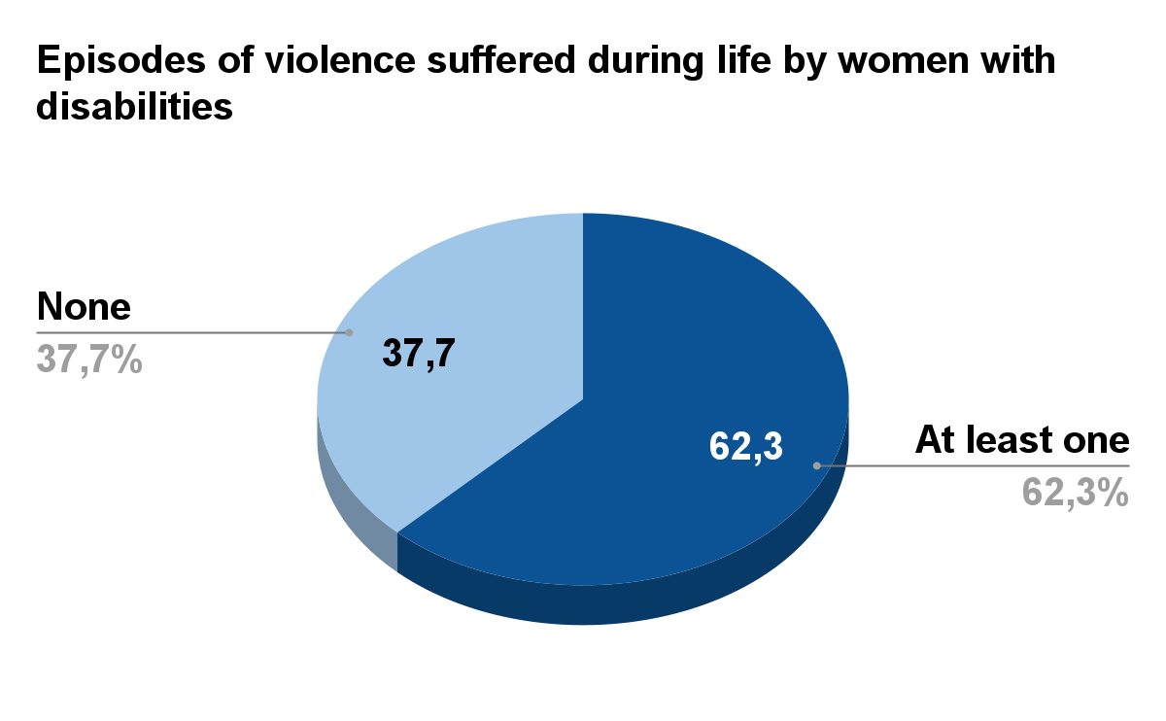
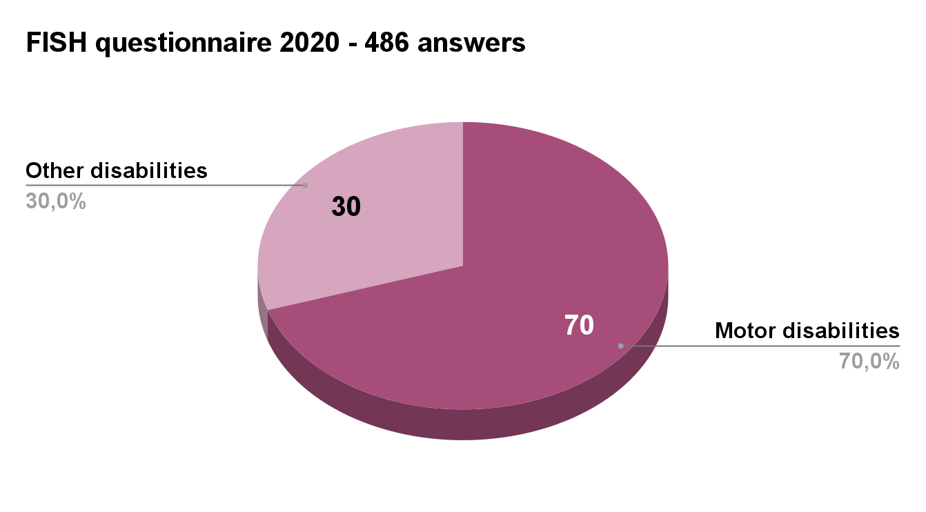

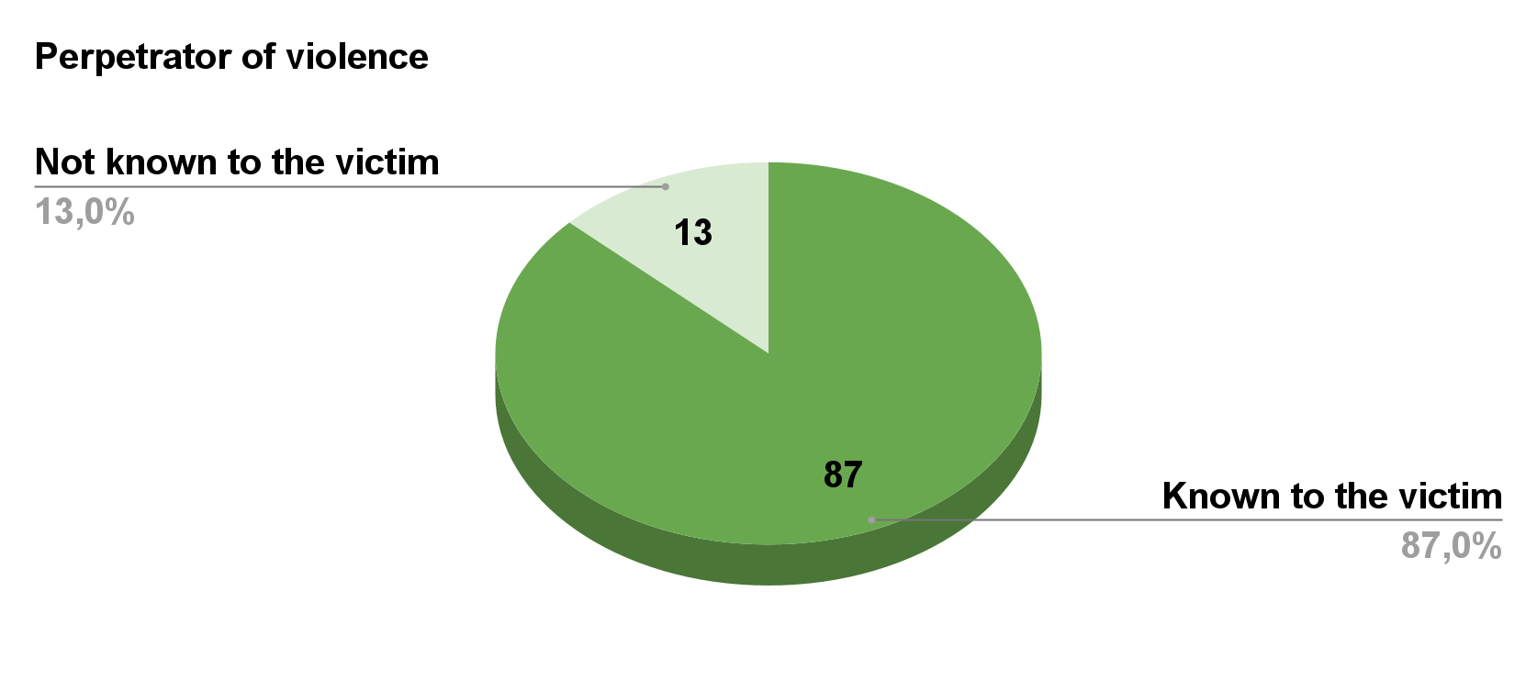

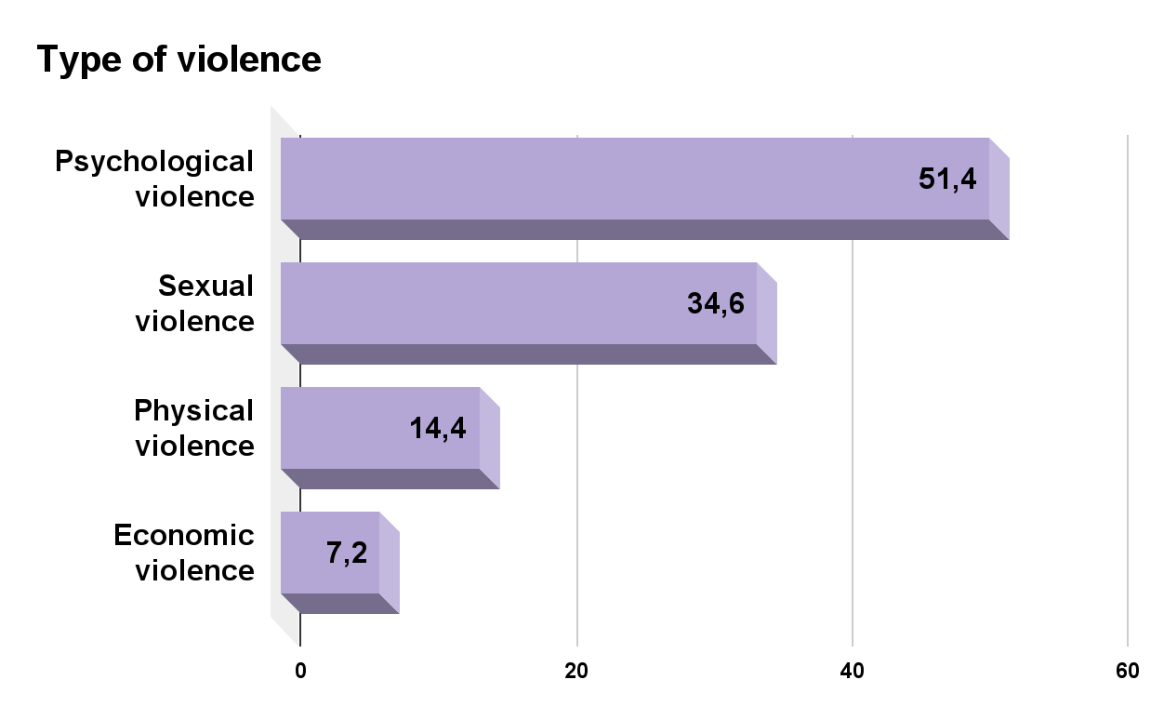

It is clear that some women with disabilities responding to the questionnaire declared that they suffered from more than one type of violence during their life.
Only 6.7% of women with disabilities reported violence to the police and only 3.5% turned to Anti-Violence Centres.
In the publication prepared by the CRIMINAL ANALYSIS SERVICE OF THE CENTRAL DIRECTORATE OF THE CRIMINAL POLICE, in addition to the general data relating to crimes committed against women in the first nine months of 2023, there is a chapter dedicated to "violence against women with disabilities" edited by the OBSERVATORY FOR SAFETY AGAINST DISCRIMINATORY ACTS, where the data disaggregated by gender and disability referring to the period 1 October 2022 - 30 September 2023 were extrapolated by inserting for the first time the search parameter disabled/invalid/handicapped .
These data refer only to the complaints submitted and therefore represent a small minority compared to those that are not reported. The comparison with the data collected the previous year highlights a notable increase, more than double, in the number of crimes regarding mistreatment (238 against 105), sexual violence (54 against 24) and persecutory/stalking acts (32 against 6).

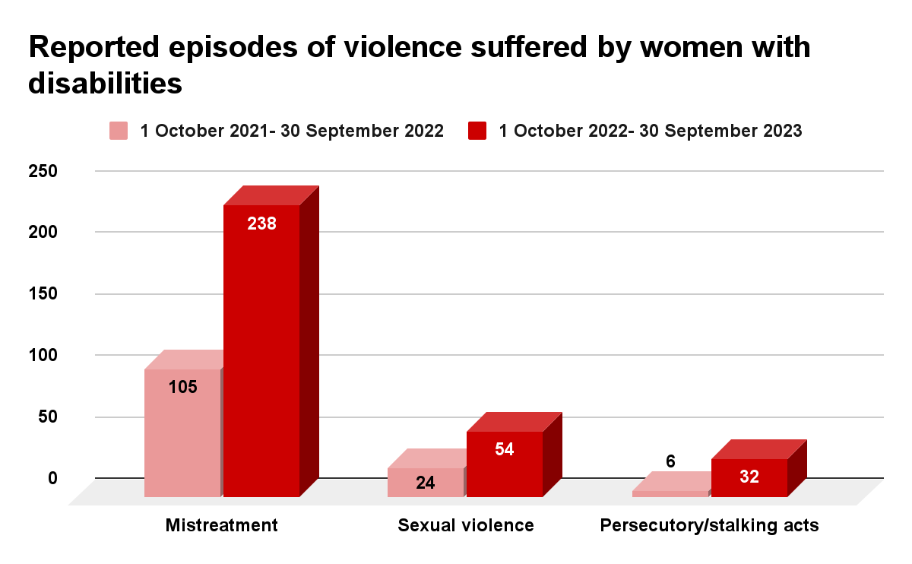

On November 25 the Minister for Family announced that a working group would be established within the Observatory which will work on the issue of violence against women with disabilities and will give all the suggestions within the Technical Committee of the National Observatory on violence against women about statistical data, information campaign, and accessibility of shelters.
Policies and legislation to combat gender violence go on a parallel track to policies and legislation on disability, thus failing to address the specific needs of women with disabilities. The intersectional discrimination that affects women with disabilities is not recognized in laws and in language.
The mapping of anti-violence centres and shelters does not include accessibility requirements: victims of violence with disabilities do not have adequate access to services. Awareness and prevention campaigns are not directed at all girls and women with disabilities and are not supported by adequate languages ​​and tools ("easy to read" format, sign language, subtitles, audio descriptions, Braille format, etc..).
The risk of being victims of hateful actions and words is also greater in the digital world, as already confirmed by the seventh map of intolerance by VOX - Italian Rights Observatory showing that women and disabled people are more subject to violent Twitter insults than other categories of marginalized persons such as the Roma, homosexuals, migrants and the Jewish.
1522 Helpline: A 37-second subtitled video communication campaign was recently created to advertise the toll-free telephone number 1522 for calling, contacting or chatting in case of violence. The testimonials are athletes, including a Paralympic woman, who convey the message: “YOU ARE NOT ALONE”.
Despite some positive signs, in general women with sensory disabilities find it difficult to access support services, e.g., when deaf sign language women arrive at anti-violence centres, communication with the staff is impossible if the staff themselves do not know Sign language. It does not appear that there is a dedicated interpreting service for deaf sign language women when they enter the facilities, except for a few exceptions. Visually impaired women who are victims of domestic violence don’t have the opportunity to reach the dedicated facility safely. It’s important to consider that they usually don’t have any support network and are not able to reach the facility independently: it would be absurd to ask the person who committed abuse against them to accompany them there. So, accessibility for them is severely limited if not precluded. A dedicated accompanying service would be needed.

Recommendations
Provide support to women with disabilities who are victims of violence already at the complaint stage and develop relevant programs and measures.
Provide accessibility services to ensure that women with sensory disabilities can access support and facilities independently from the stage of reporting the crime.
Collect disaggregated data also by disability, and type of disability, on the phenomenon of secondary victimization.

Trafficking and exploitation of prostitution

Currently, it is not possible to know whether girls and women with disabilities are forced, before leaving their countries, to marry men in migratory flows to Italy, in order for such men to avoid expulsion proceedings when in Italy.
SR 175: In the cited National Anti-Trafficking Strategic Plan 2022-2025 the State party Italy does not mention the expected results and related operational measures for its implementation. Moreover, in this plan the disability perspective is missing. There is a lack of information on the results of any monitoring activities of the efficiency and effectiveness of this Plan.

Recommendation

Provide evidence on the implementation of the Anti-Trafficking Plan and the results obtained also on girls and women with disabilities.

Education

Data on Italy from the European Institute on Gender Equality (EIGE), Gender Equality Index on Graduates of tertiary education showed that 11% of women with disabilities completed successfully their highest educational level compared to 10% of men with disabilities. Far from the percentages of women without disabilities 21%, and men without disabilities 17%.

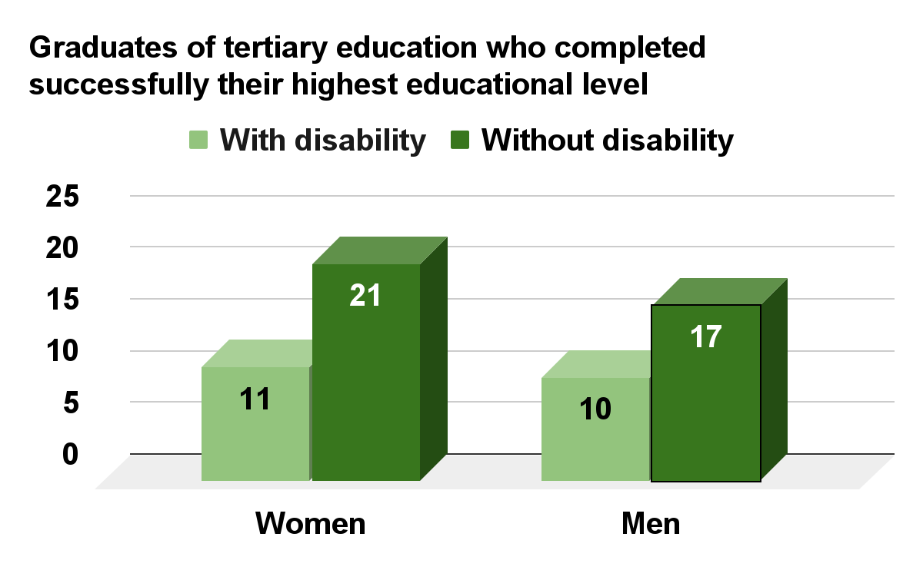

In this chapter of the State party Report, Italy gave a great deal of information regarding the access to education for women. This information, though, is not useful to describe and measure discrimination against girls and women with disabilities.

Considering SR 197 (c) the promotion of early childhood education services has failed. According to publication of Ministry of Education-Office of Statistics, Focus “Key school data -
Opening of the 2022-2023 school year” the access to services related to early childhood (crèches and pre-compulsory schools) has a lower-than-average presence of children with disabilities (only 2.3% compared to a 7% presence in primary schools) also due to the shortage of specialized staff in these services. This data reveals the fact that pre-school children with disabilities are often kept at home, a factor that fuels discrimination and isolation in the crucial years of development and, above all, places the burden of their care and education on their mothers with also a problem for reconciling work and family life.
Students with disabilities in the school year 2018/2019 are just under 284,000, equal to 3.3% of the total number of students, close to 8.6 million.

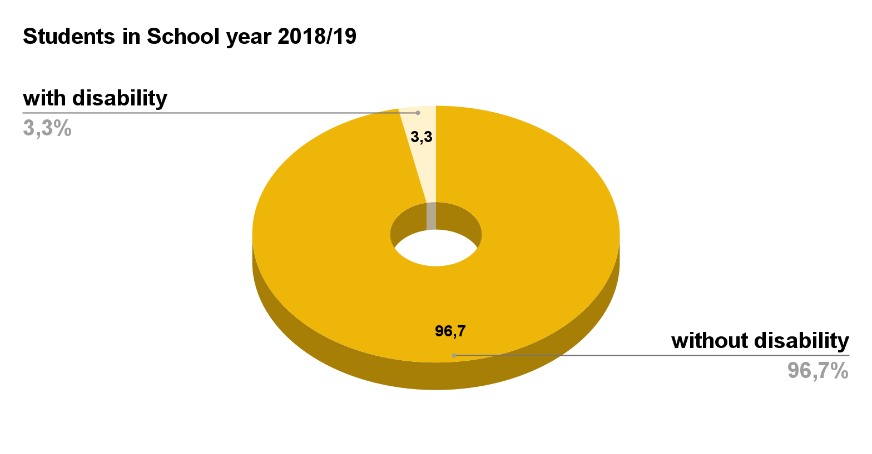
With 34,767 students with disabilities, nursery school shows a percentage of 2.4% of the total number of students attending; the percentage is 3.8% in primary school and 4.2% in lower secondary school. In upper secondary school, the percentage of students with disabilities stands at 2.7% of the total attendees.

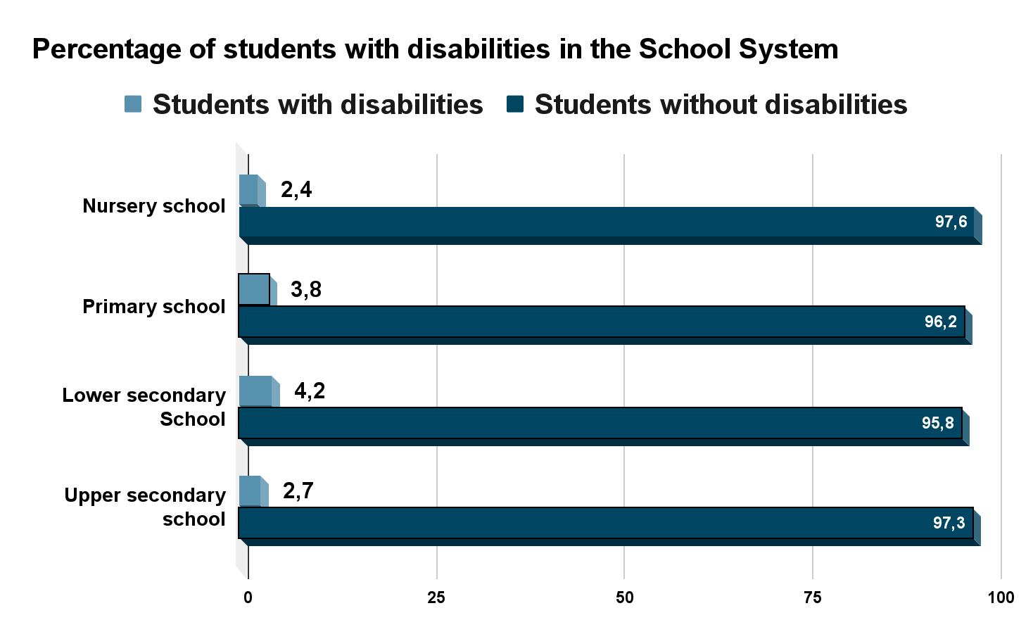

Graduates in the science-technology-engineering (STEM) disciplines in 2017 are 26.5% of the total number of graduates, with a predominance of the male component (59.0%), while among non-STEM graduates, women prevail (they are almost two out of three).

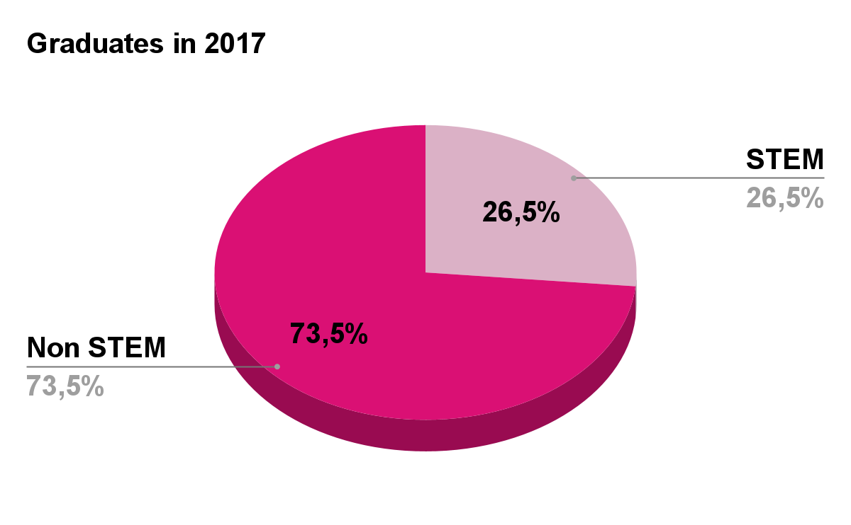
Among STEM graduates, the male component is high, especially in the engineering (74.0%) and science (68.4%) groups. This data is about all graduates with and without disability.

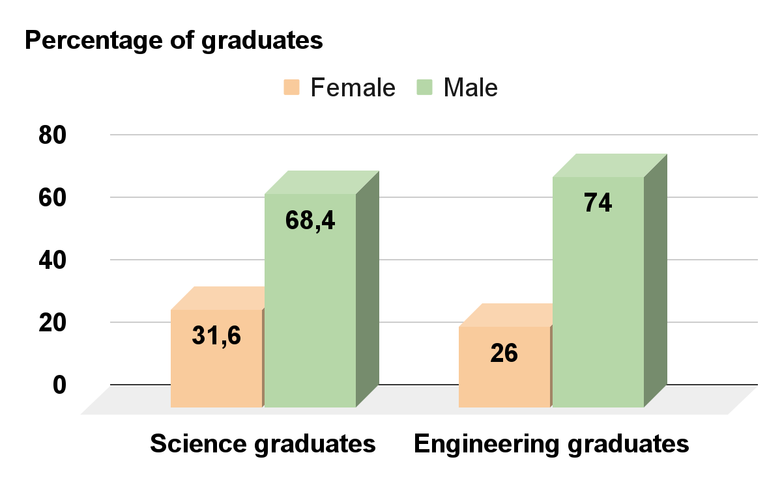

Based on observation and personal experience coming from FID members, the gap is even higher when it comes to women with disabilities, especially women with visual impairments. It is a gap that we can largely attribute to the inaccessibility of texts and materials as well as to stereotypes and prejudices at a social and cultural level. (SR 199).

Recommendations
Design, adopt and use appropriate indicators to monitor the quality of inclusion and education of pupils and students with disabilities in schools and in single classes;
Enhance the access to universities, including to postgraduate courses, through the uniform provision of services and assistive technologies which are appropriate to meet the needs of students with all kinds of disabilities.

Employment

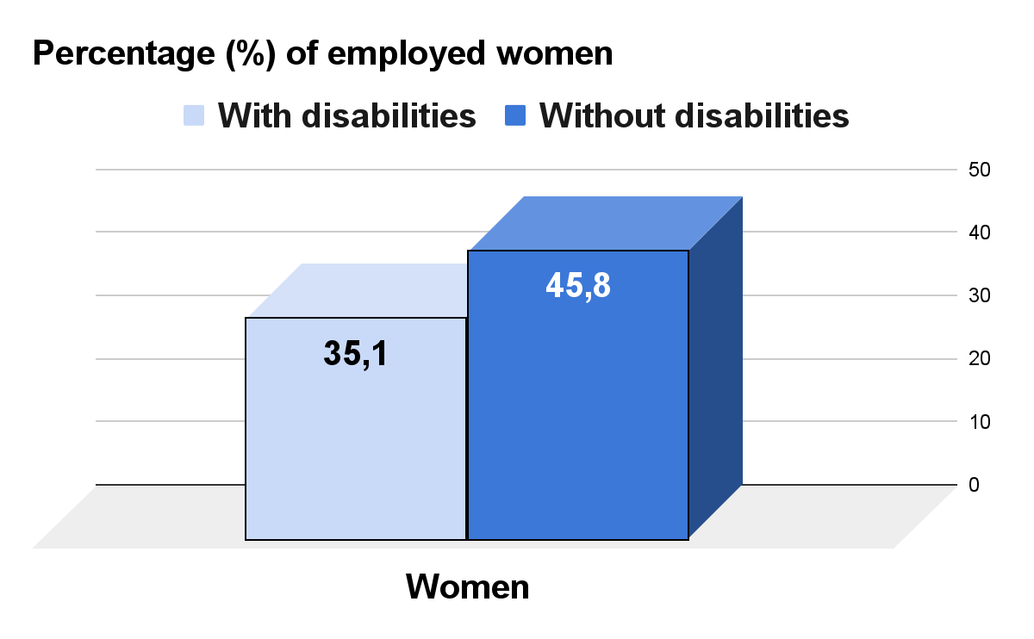
Among women with disabilities of working age, only 35.1% have a job, compared to 52.5% of men with disabilities, 64.6% of the male population and 45.8% of the female population, with an employment disadvantage of women with disabilities compared to men in the same situation of 17.4%.

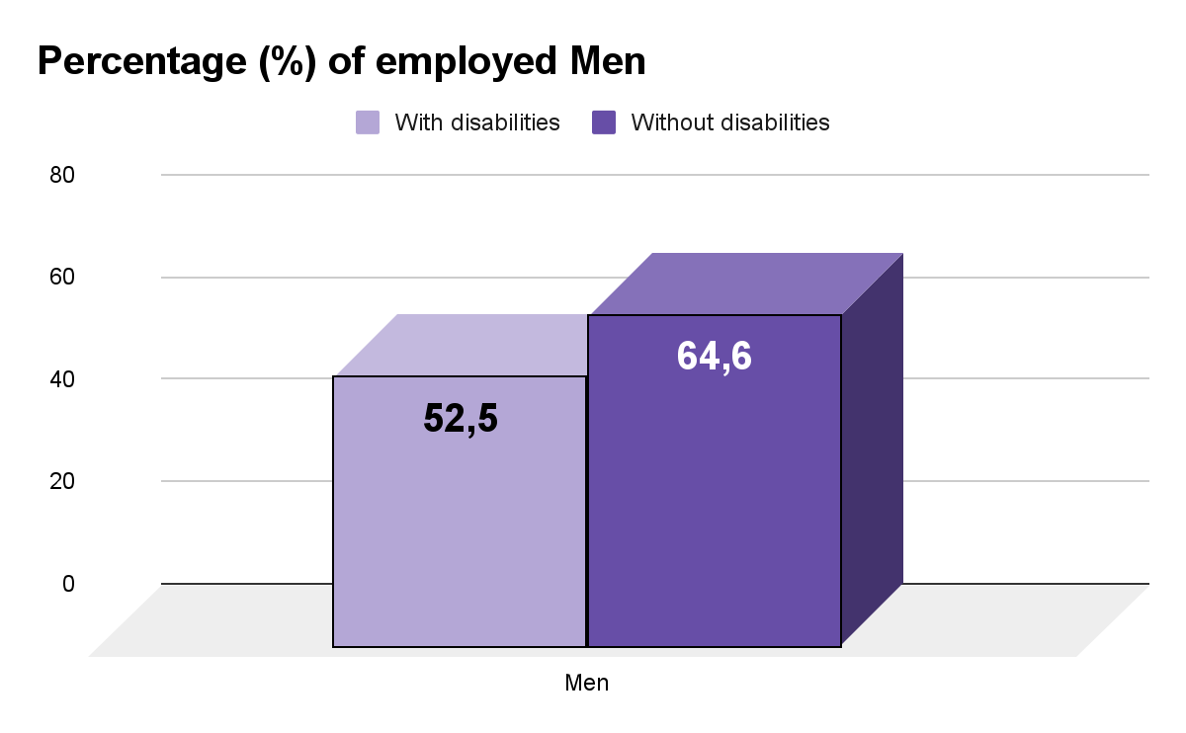

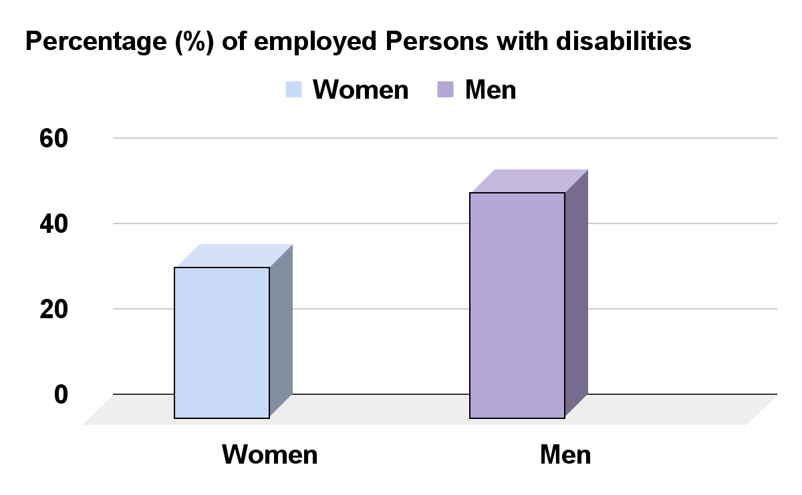

The situation is even worse when considering full-time employment: only 14.1% of women with disabilities have a full-time job compared to 28% of men with disabilities and 41.2% of the female population.

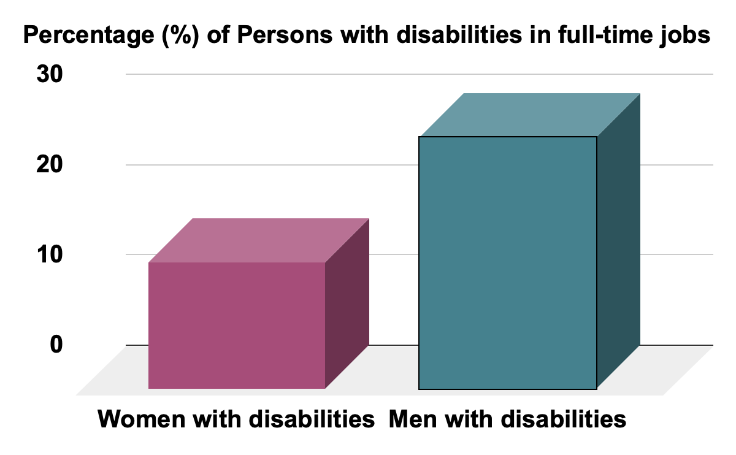
-

The 10th Report to Parliament on the state of implementation of Law of 12 March 1999, n. 68, published in March 2023, with only 2019 data on the employment conditions of persons with disabilities, shows a gap in access to employment for women with disabilities. In general, there is limited enforcement of the law. In fact, there are still 114,111 compulsory but unfulfilled jobs in the private business sector, and 34,118 in the public business sector for a total of 148,229. The total number of people employed in the public and private sector is 44,318, of whom only 18,397 (41.5%) are women.
Persons caring for family members with disabilities, the overwhelming majority of whom are women, suffer from intersectional discrimination to the detriment of paid employment, due to the difficulties of reconciling work and care activities.
The availability of support services and facilities is crucial to allow persons with family care responsibilities to maintain a healthy balance between care tasks and working life, especially for women, who, in Italy, are involved in the care of elderly or family members with disabilities to a greater extent than men.
A CENSIS study highlighted the negative impact of disability on the working life of the majority (65.9%) of parents of persons with disabilities. Mothers suffer a higher rate of discrimination (62.6%) than fathers (25.5%) and the general female population (44%). 25.9% of mothers left or lost their jobs, while 23.4% reduced their working hours, compared to 11.3% of fathers.
In October 2022, Italy received a CRPD Committee Decision that noticed that Italy's failure to provide individualized support services to a family of persons with disabilities was discriminatory and violated their rights to family life, independent living and an adequate standard of living. Moreover, it introduced the concept of “discrimination by association.”
Data on Italy from the European Institute on Gender Equality (EIGE), Gender Equality Index on “Capacity to take an hour or two off during working hours to attend to personal or family matters“showed that only 34.2 % of female workers with disabilities were able to do so, compared to 45.1 % of male workers with disabilities.
ISTAT, in its Update Note to the Economic and Financial Document 2020, notes that the pandemic seems to have exacerbated pre-existing gender gaps in labor market participation.
The effects of the employment crisis resulting from the health emergency mainly affected women, who even before the pandemic suffered the most difficult working conditions, causing between February and August 2020 a more pronounced decline in employment for women (-2.1% versus -1.1% for men), while in August the recovery in employment affected men (+ 0.5%) more than women (+ 0.1%).
Among the annexes of the SR 215 (Annex 10), which contains data on the risk of poverty, we take this Annex as a starting point to introduce our remarks with reference to Article 13 of this Convention to introduce the violation of this article by State party Italy.
The employment disadvantage of women with disabilities together with the additional disability-related expenses for health care, specialist care, the purchase of medical aids, and the removal of architectural barriers in the home negatively affect the economic status of women with disabilities, exposing them to a higher risk of poverty and dependence on others.
According to the money indicators in Italy of the EIGE Gender Equality Index , the average monthly income of women with disabilities (1840 Euro) is lower than that of men with disabilities (2590 Euro) and the general female population (1869 Euro). The average equivalent net income of women with disabilities is 17875 Euro compared to 18703 Euro for men with disabilities and 19481 Euro for the general female population. The same EIGE Gender Equality Index says that in Italy, the informal support network plays a significant role since the welfare model in our country continues to be family-based. About 35% of women and men report a need for professional home care services unmet.
Regarding the same point, we must underline that: The lack of support services for persons with disabilities has a dramatic impact on families, who are often left alone to take care of family members with disabilities.
This has a disproportionate impact on both the health and economic conditions of women as major caregivers of family members with disabilities, whose life expectancy, according to Nobel Prize winner Elisabeth Blackburn, is 9 to 17 years shorter than the general population. Nevertheless, the caring role of caregivers is neither recognized nor protected by law.
Disability may lead to extra costs for individuals and households with disabilities. These expenditures may relate to general items that any household may need (e.g., health care, food) as well as to disability-specific items (e.g., assistive devices, rehabilitation, personal assistance, and house adaptation). The lack of services, the scarcity of the social protection programs, the absence of fair and regular benefits from social protection programs may provide a lower standard of living for persons with disabilities due to the extra costs they face. This is the reason why the presence of a person with a disability can reduce resources and economic conditions and impoverish the family's lifestyle, both by significantly increasing disability-related costs both making it more difficult to find or keep a job and to obtain satisfactory wages, especially for women.
The economic crisis resulting from the pandemic containment measures has further worsened the socio-economic conditions of both persons with disabilities and women caring for family members with disabilities. The closure of schools and day care services for persons with disabilities has disproportionately impacted on women as the main care providers, increasing the burden of domestic care work, hindering their participation in the labor market and economic independence, thus increasing the domestic divide between partners and the risk of domestic violence.

Recommendations
It is crucial to develop systematic investigations and research studies on inter-sectorial discrimination affecting women and girls with disabilities, on their participation in social life and their access to equal opportunities in all areas of life, including employment.
It is necessary to guarantee economic measures and direct interventions already from the next Budget Law, first of all on the funds concerning persons with disabilities and their families, which cannot be questioned or reduced but increased.

Health

Referring to our previous 2021 document to your Committee on this topic, we reiterate that women with disabilities face several barriers hindering their equal access to health care and disease prevention programs. According to the 2023 gender equality index in health, 6% of women with disabilities considered having unmet needs for medical examination compared to 4% of men with disabilities and 2% of other women.
A Parliament Resolution was recently passed calling on the Government to make a commitment to improve access to health services for persons with disabilities. We await to know its effects.
Blind and partly sighted women find it difficult to go to medical services independently. In the sphere of sexual and reproductive health, there is also a privacy problem. There is a need for an accompanying service provided for visually impaired women, while for sign language deaf women there is a communication problem when interacting with health professionals.
Unfortunately, sometimes women with disabilities do not get to be aware of their rights because information is not conveyed in a way that is understandable and accessible to those who should be able to benefit from it.
Regarding the SR 264 we must underline that: Approximately 20% of children have impairments related to the diagnosis of “neuropsychological or neurodevelopmental disorder”, which would be the main cause of disability in the 0-17 age group. Although the number of children taken into care by specialist services has increased, in Italy only one out of two children manage to access diagnostic services, and only 1 out of 3 manage to access the rehabilitation intervention they need.
Recalling January 2021 FID Written Submission to CEDAW Committee on CEDAW Article 12 (Health), FID is providing the following considerations about SR 267 regarding the access to sexual and reproductive health and rights. Women and girls with disabilities are still confronted with many forms of discrimination in all areas of life. Because of myths, stereotypes, and lack of knowledge of disability, they face discriminatory treatment and abuses that particularly affect their sexual and reproductive health and rights, with important and sometimes irreparable consequences on their lives. Menstrual management, forced sterilization, forced contraception, and coerced abortion are just some examples of denial of rights that many women and adolescents with disabilities suffer, without giving their consent or fully understanding the aims and consequences implied. Women and girls with high support needs, intellectual or psychosocial disabilities, women who are deafblind and those with multiple disabilities, and particularly those living in institutional settings , are particularly vulnerable to such abuses.
Women with disabilities are rarely supported throughout motherhood and face multiple barriers to reproductive and adoption services. The barriers are not only physical but also cultural, preventing women with disabilities from fully and adequately accessing essential gynecological treatments. The pandemic has worsened an already critical situation.
In March 2022, the FID member UILDM carried out a survey 9 years after a previous one. Unfortunately, nothing has changed. The combination of the inaccessibility of gynecological facilities, in addition to the denial of one's femininity and all undermining behaviors, ends up acting as a deterrent to gynecological health care and prevention for girls and women with disabilities.
None of the measures described in the State Report on the issue of Reproductive Health are available for girls and women with disabilities, due to cultural gaps and accessibility issues. According to the above-mentioned UILDM report, only four centres throughout Italy provide quality services specific to their needs and disabilities. Of these four centres only one, notably the Rosa point at the Florence Careggi Hospital, is just available for women with motor and sensory disabilities, while the ASDI service is not gender specific and sedation is the only tool available to women with intellectual and developmental disabilities to access reproductive health services.

Recommendation
Adopt protocols and guidelines ensuring equal access to general health-care services for girls and women with disabilities, notably to the female reproductive health and childbirth services, design and plan specific investigation on the phenomenon of forced sterilization of girls and women with disabilities.

Refugee, asylum-seeking and migrant women

The Integration Reception System (SAI) consists of the network of local authorities resorting to the National Fund for Asylum Policies and Services in order to implement integrated reception projects. According to this SAI system, in August 2023, out of 797 funded places for persons with mental distress or disabilities, only 573 people were accepted into the projects. There is no data available allowing us to understand how many women with disabilities are included. (SR 278).

Recommendation
Develop and collect data on the presence of girls and women with disabilities in the SAI projects devoted to persons with disabilities. The data must be disaggregated by age and type of disabilities.

Additional information

The Committee should be informed that in SR322 of the State party Report, the Bill mentioned was rejected in the Senate on 27 October 2022.

The title of the bill was “Measures to prevent and combat discrimination and violence on grounds of sex, gender, sexual orientation, gender identity and disability”.

ISTAT: National Institute of Statistics
This information is present in the specific chapter of VAW.
With the delegating law, parliament empowers the government to regulate a matter by defining general guidelines. The executive then outlines the detailed rules with one or more legislative decrees.
Article 6 of the UN CRPD, ratified in Italy with Law No. 18 of 2009, while recognizing that women with disabilities are subject to multiple discrimination, gives no definition of this expression. Intersectional discrimination occurs when discrimination is based on several factors that interact with each other in such a way that they can no longer be distinguished and separated. The resulting consequences are inseparable and can only be assessed because they form a new discrimination, which is no longer merely the sum of the effects resulting from the individual factors involved.
Essential level of care services (LEPs). LEPs are the essential levels of benefits and services that must be guaranteed uniformly throughout the national territory.
https://www.istat.it/it/archivio/161716
https://www.fishonlus.it/la-violenza-sulle-donne-con-disabilita-i-dati-e-i-fatti/
https://www.interno.gov.it/it/notizie/punto-pregiudizio-e-violenza-contro-donne-presentato-roma-report-servizio-analisi-criminale
ISTAT: Inclusione sociale delle persone con limitazioni funzionali, invalidità o cronicità gravi, 2015 https://www.istat.it/it/files/2015/07/Inclusione-sociale-persone-con-limitazioni-funzionali_def_240715.pdf?title=Limitazioni+funzioni%2C+invalidità%2Ccronicità+gravi+-+21%2Flug%2F2015+-+Testo+integrale.pdf
https://eige.europa.eu/gender-equality-index/2022/domain/work/IT/disability
ISTAT: “Come cambia la vita delle donne”, https://www.istat.it/it/archivio/176768
CENSIS - Fondazione Serono: “"The hidden dimension of disability", 2011 http://www.censis.it/5?shadow_evento=117959
CENSIS: 46° Report on the social situation of the Country: “Caregivers, women on the front line”, 2012
ISTAT, Nota sulla legge “Dopo di noi”, 2017 https://www.istat.it/it/files/2017/06/A-Dopo-di-noi.pdf
SARA (Spousal Assault Risk Assessment
The resolution is one of the acts by which Parliament directs the Government. It has no formal but merely procedural value, it does not legally affect the life of the Government
https://www.salute.gov.it/portale/saluteMentale/dettaglioContenutiSaluteMentale.jsp?lingua=italiano&id=5621&area=salute%20mentale&menu=azioni
https://www.quotidianosanita.it/allegati/allegato8398665.pdf Guidelines on neuropsychiatric and neuropsychological disorders in childhood and adolescence. Page 9
https://www.lasicilia.it/news/cronaca/365594/troina-la-violenza-shock-su-una-disabile-scoperta-perche-la-ragazza-e-rimasta-incinta.html
https://www.uildm.org/sites/default/files/Report%20Donne%20Sessualit%C3%A0_UILDM.pdf
Sant'Anna Hospital, Turin; 'Fior di Loto' Outpatient Clinic ASL Turin; 'Al Quadraro' Consultatory, Rome; AmBulatori Aou Careggi Florence. The latter has a service (Rosa Point Service) for motor and sensory disabilities and one for intellectual disabilities (ASDI Service -Assistenza Sanitaria DIsabilità).

