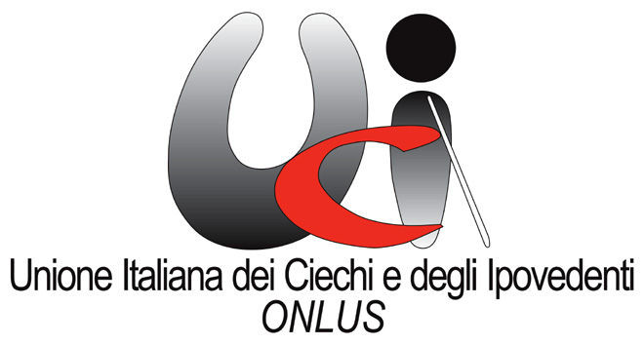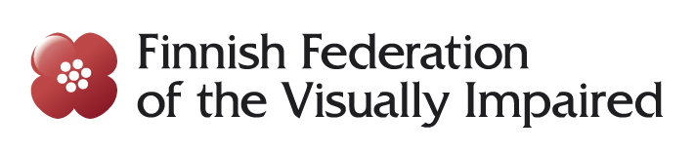

Manifesto
on the accessibility of sports
and sport facilities

Adapted physical activities and sports have for children and adults with visual impairment the value of enhancing their abilities and what they can do, in a world that constantly reminds them of what is missing and what they are not able to perform. Those activities, both in the form of individual and team sports, are aimed at developing not only motor skills in general, space perception and orientation, but also social and relational skills, inclusion and successful peer-to-peer cooperation due to the recognition of shared values.

Unfortunately, physical education teachers and sports instructors are rarely in possession of the necessary knowledge to allow blind people to play sports. The high value of sport for people with disabilities makes it necessary to promote sport education for children and adults with visual disabilities, by means of awareness–raising initiatives and activities organised in schools first of all, but also in private gyms and targeting the general public.

The purpose of this Manifesto is therefore to highlight a number of issues in the field of sport for persons with disabilities that require action by local, regional and national authorities to bring about a cultural shift towards a truly inclusive society.

We ask for

- the promotion of a training for teachers, and in particular for physical education teachers, on the sports that can be played by children and adults with visual disabilities

- enabling students with disabilities to play sports with their peers at school thanks to the adaptation of equipment and / or sporting regulations

- Governments to fund as a priority measure the architectural adaptation of school gyms and other public gyms so that they are fully accessible to people with disabilities and to promote the same kind of adaptations in private sport premises

- sport federations to encourage the study of adaptations enabling people with visual disabilities to play sports and to support the training and activities of coaches and referees who decide to specialize in sports for people with disabilities, without discriminating between Paralympic and non-Paralympic sports.

- the involvement of people with disabilities and the organizations that represent them in sports activities organized at local, regional and national level, as well as in conferences and youth exchanges on sports

- more awareness-raising events and demonstrative activities to help persons with disabilities to get into sports

It is important to recall that the inclusion of people with visual disabilities is fully implemented only when the adaptations that are necessary to ensure that these people have full access to everybody’s activities are implemented in society and in the built environment. For this reason it is necessary to use specific tools for the adaptation of “ordinary” sports, allowing visually impaired people to play them, (eg. baseball, fencing, etc.) and for playing sports specific for the blind, but that can also be played by blindfolded sighted people (torball, show-down, etc.). These tools and adaptations do not always entail significant additional expenses and often they only require the adoption of simple measures such as:

- guidance paths on floors and walls of the corridors and locker rooms of gyms with different texture and colours
- sport fields and courts with ground signals in contrasting colours
- Braille labels (such as those produced with the dymo tape) as an alternative to inkprint signs
- balls with bells inside torball, goalball and baseball, etc.
- accessibility of the websites of gyms and sport clubs
- sport fields and courts that are designed for playing different sports, including sports for the blind and people with other disabilities

This Manifesto was drafted in 2016 by the participants of the "SportAbility: equality and participation through sports" project co-financed by the European Union

